# **C3-S8 –PRACTICE**

## EX1

Convert this tree to python

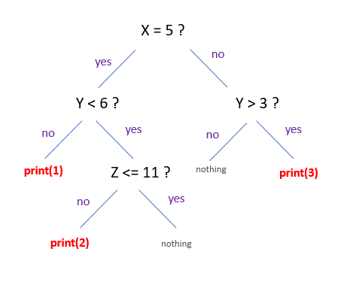

x = 0

y = 0

z = 0

if x == 5:

    if y > 3:

        print(3)

elif y < 6:

    if z >= 11:

        print(2)

else:

    print(1)

## EX2

Converts this tree to python

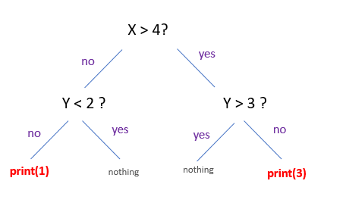

x = 0

y = 0

z = 0

if x >4:

    if y <3:

        print(3)

    else:

        print("nothing")

else:

    y>2

    print(1)

## EX3

* Create variable name “**nbRepeat**” and set the values to 5
* Print « Hello World » following variable**« nbRepeate »** times

**It should print this:**

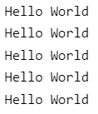

nbRepeat = int(input())

for i in range(nbRepeat):

    print("Hello World")

## EX4

Create variable name “**number**” set the value to 20

As long as when the number still greater than 5

* Print “**number**”
* Increment number of -2

**It should print this:**

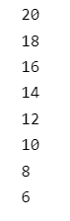

number = 20

while number >5:

        print(number)

        number += -2

## EX5

* Create 2 variables
* name = “Tola”
* age = 21

You shall write the value of those 2 variables with some text, as show on the result

It should print this:

**My name is : Tola, I am : 21 years old !**

name = "Tola"

age = 12

print( "My name is:",name,"I am:" , age, "yeears old!")

## EX6

Get the number **entered from keyboard** and store it into a variable **userMessage**

* If the **userMessage** is lower than 0, display “Negative Number!”
* Else display “Positive Number”

**Example:**

If user enters -1:

**Negative Number!**

If user enters 5:

**Positive Number!**

number = int(input())

if number < 0 :

    print("Negative Number!")

else:

    number > 0

    print("Positive Number")

## EX7

Example: To see "Dog" number must be in the range: **] –infinity, 25[**

|  |
| --- |
| if number < 25 :  print(« Dog »)  elif number <= 30 :  print(«Cat»)  else :  print(«Cow ») |

Q1: What must be the range of number to see "Cat"?

] -infinity, 30 [

Q2: What must be the range of number to see "Cow"?

] 30,+ infinity[

## EX8

What will be print if value equal to 10?

|  |
| --- |
| if value >= 5 :  print(« Apple »)  elif value <= 10 :  print(«Banana») |

Answer: Apple

## EX9

What will be print if value equal to 10?

|  |
| --- |
| if value >10 :  print(« Red »)  if value <= 10 :  print(«Blue») |

Answer: Blue

## EX9

- Enter a string **text** in the console

- **n** is the length of **text**

- Print **n** times of the character "X”

Case 1:

>test

>X X X X

Case 2:

>tryagain

>X X X X X X X X

text = input("")

n = len(text)

for i in range(n):

    print("x",end="")

## EX10

-Enter a number **n** in the console

-Print a reversed triangle of “X”

Exemple:

>5

>X

>X X

>X X X

>X X X X

>X X X X X

>2

>X

>X X

text = int(input())

for i in range(1, text + 1):

    for j in range(1, i +1):

        print("x",end="")

    print("")

## EX11

-Enter a number **n** in the console

-Print a reversed using numbers (see example)

Example:

>5

>12345

>1234

>123

>12

>1

>2

>12

>1

n=int(input())

for i in range(n,0, -1):

    for z in range(1, i+1):

        print(z,end="")

    print("\n")

## EX12

- Enter a string **word** in the console

- Print “X” on the console (see example)

Exemple:

>hello

>XXXXX

>testing

>XXXXXXX

text = input()

for i in range(len(text)):

    print("x",end="")

## EX13

- Enter a string **word** in the console

- Enter the number **n** in the console

- If **word** equal to “good” and the number between 7 and 15, it’s will be print “It’s good”

- If **word** equal to “bad” and the number lower than 7 or greater than 15, it’s will be print “It’s bad”

Exemple:

>good

>10

>It’s good

>bad

>6

>It’s bad

text = input()

number = int(input())

n =  text

n = number

if n >7 and n <15:

    print("It's good")

if n <7 or  n>15:

    print("It's bad")

## EX14

- Enter a number **n** in the console

- Print a reversed using numbers (see example)

Exemple:

>5

>1

>2 3

>4 5 6

>7 8 9 10

>11 12 13 14 15

Example :

>3

>1

>2 3

>4 5 6

rows = int(input())

number = 1

for i in range(1, rows+1):

    for j in range(1, i+1):

        print(number, end=" ")

        number += 1

    print("")